

## A Project report on “eBabyCare”

**Submitted by**

Jannatul Ferdous Shova

ID: 182-35-2568

Batch: 26th

Department of Software Engineering

Daffodil International University

**Supervised By** Md. Shohel Arman Senior Lecturer

Department of Software Engineering Daffodil International University

This project has been submitted in fulfillment of the requirements for the degree of Bachelor of Science in Software Engineering

© Daffodil International University

# APPROVAL OF PROJECT

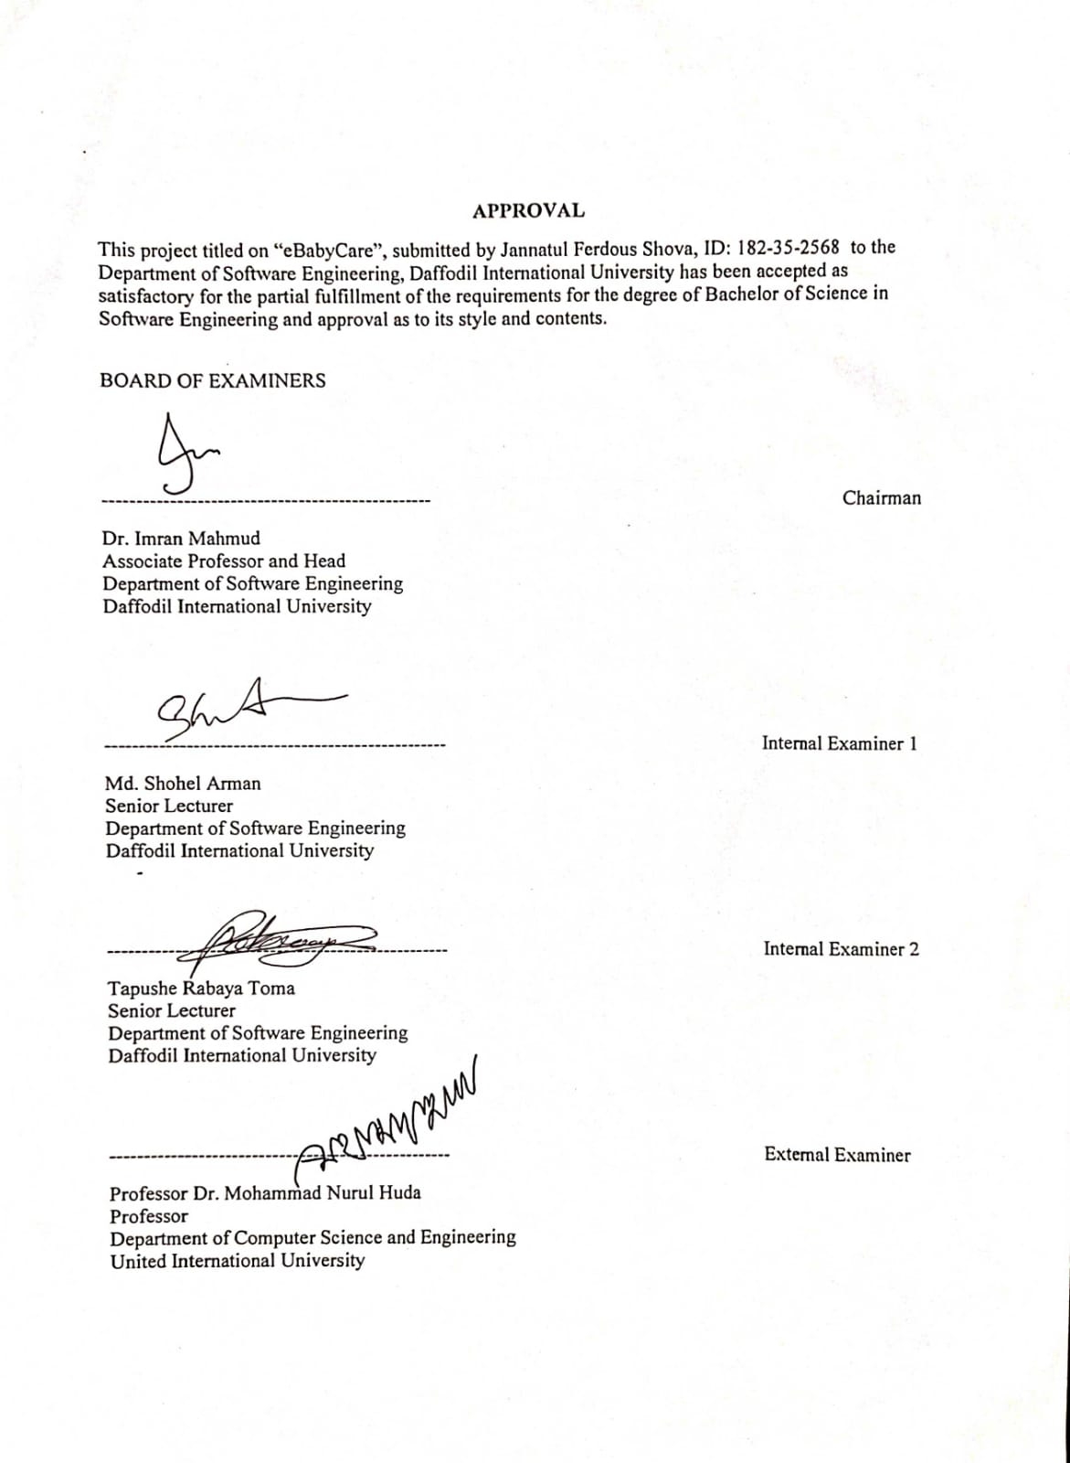

# DECLARATION

I hereby declare that I have done this project under the supervision of Md. Shohel Arman, Senior Lecturer, Department of Software Engineering, Daffodil International University. I also declare that this project or any part of this is unique and has not been submitted elsewhere for the award of any degree.

Submitted By:



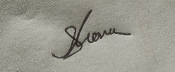

jannatul Ferdous Shova

ID: 182-35-2568

Department of Software Engineering

Faculty of Science and Information Technology Daffodil International University

Certified By:



Md. Shohel Arman Senior Lecturer

Department of Software Engineering

Faculty of Science and Information Technology Daffodil International University

# ACKNOWLEDGEMENT

I would like to express my heartfelt gratitude to the Almighty Allah who offered upon my family and me kind care throughout this journey until the fulfillment of this project.

Also I would like to thank my honorable supervisor Md. Shohel Arman, Senior Lecturer, Department of Software Engineering, Daffodil International University for their proper guidance, help, support and cooperation. Without whom this project work would not be complete.

I would like to thank my entire course mate in Daffodil International University, who took part in this discussion while completing the course work. Finally, I am so grateful to my parents that I was consistently supported by them. They always prioritize my opinion and inspire me also.

# ABSTRACT

In today’s world, raising a child is a great issue for working parents. In most cases finding a nanny or trustable a helping hand is extremely difficult to find. On the other hand, there are still no part-time job sectors for our high-school kids and college kids as well(14 or above). Most of them are mature enough to take care of a toddler or young kids.   
  
My project “**eBabyCare**” is going to make a bridge between these two. It will help these parents to find a trustable person for a certain period of time and help those kids to earn some pocket money by taking care of a baby.

**Chapter 1 Introduction**

Our traditional economic system does not allow a high school kid to earn the pocket money he needs. Thus they are not able to know about money management until college or in some cases after varsity. eBabyCare could be a platform to solve this problem for them. make an earning source.

On the contrary, raising a child is a great issue for working parents. In most cases finding a nanny or trustworthy helping hand is extremely difficult to find. On the other hand, there are still no part-time job sectors for our high-school kids and college kids as well (14 or above). Most of them are mature enough to take care of a toddler or young kids.  
  
“**eBabyCare**” is going to make a bridge between these two. It will help these parents to find a trustable person for a certain period of time and help those kids to earn some pocket money by taking care of a baby.

## Project Purpose

The main purpose of this project is to introduce a platform to the teenage students as well as the working parents. This platform will create a earning opportunity for the teens and also help the working parents balance between parenting their children and not compromising their working life.

* + - Providing an earning platform for students.
    - Providing an efficient way to take care of children

## Stakeholders

There will be three types of stakeholders in our project.

1. Admin - who will control the overall workflow , bookings and appointing nanny.
2. Parents/Client - create account and book nanny/babysitter
3. Babysitter/nanny - will apply and babysit via this platform.

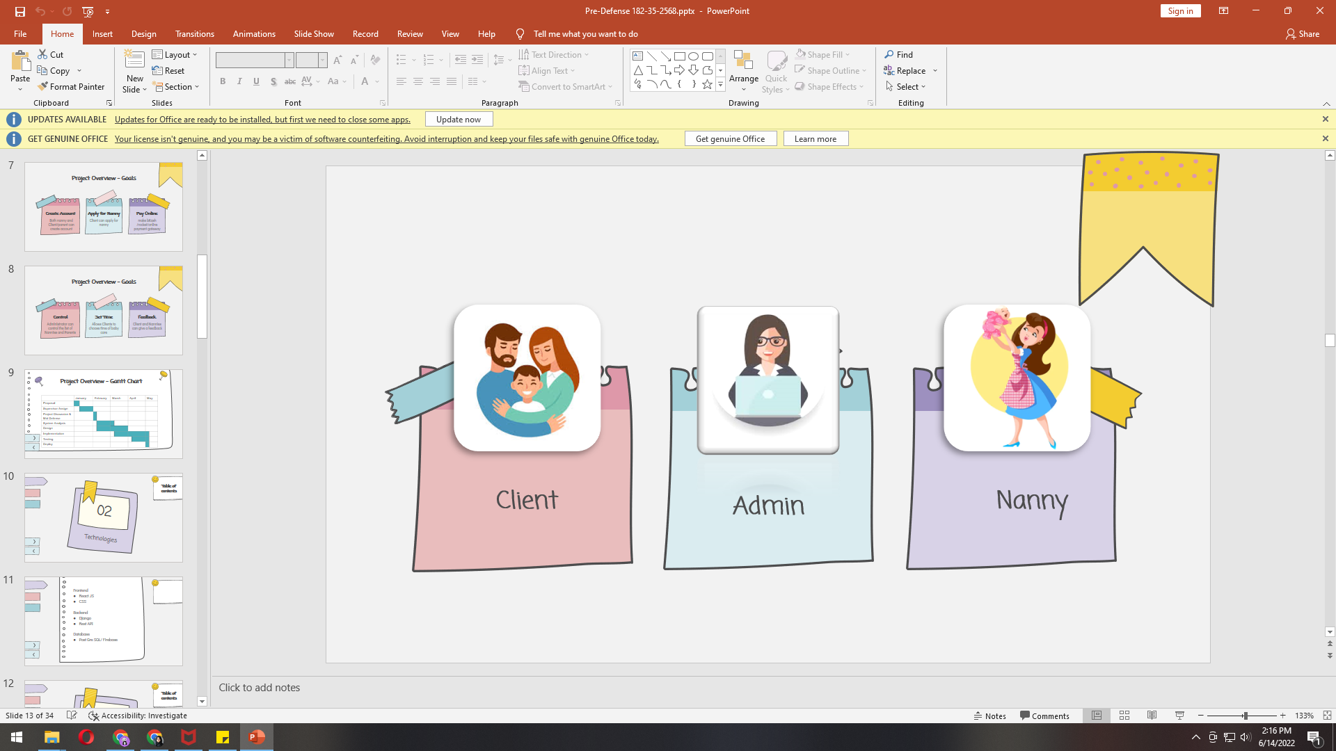

## 

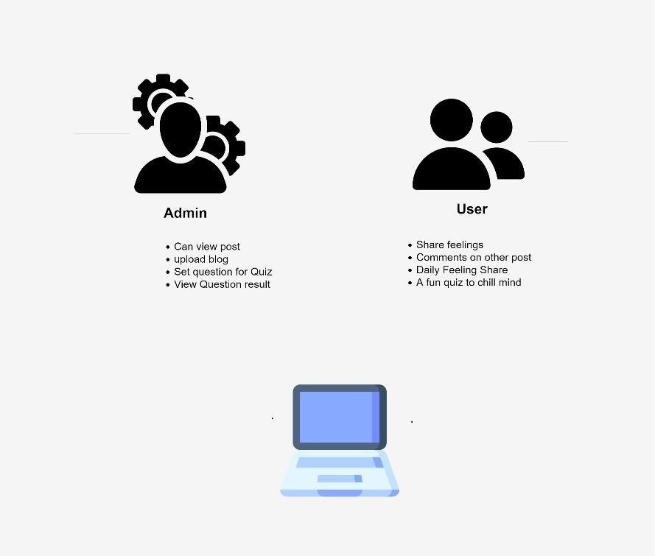

Figure 1.1: Proposed System Model

## Modules of This Systems

* + - Login: For users’ authentication
    - Registration: For Managing all users in the system
    - Profile Module: for all verified users
    - Booking: book Babysitter.
    - View Module: For viewed all activities
    - Upload Module: For users to upload post & admin to upload blog
    - Edit Module: For admin to edit uploaded blog
    - Delete Module: For Admin to delete Unnecessary things

# CHAPTER 2 REQUIREMENT ENGINEERING

Functional requirement defines a function of a system which describes the services of the system that must be offered. Functional requirement describes the main component of the system. It defines everything that a software or a system must do, the software’s functions and features. It will describe particular behavior of function of the system when certain conditions are met. It is important to make them clear for the stakeholders.

Here is the functional requirements of my project:

## Login/Logout

|  |  |
| --- | --- |
| **FR 1** | Login / Logout |
| Description | Traveler must be log in their account when they want to book any  service, and vendor must be log in when they want to post or upload something or view any details. |
| Stakeholders | Admin, User |

## Registration

|  |  |
| --- | --- |
| **FR 2** | Registration |
| Description | User must be register to log in to the system |
| Stakeholders | Admin, Parent, babysitter |

## Profile

|  |  |
| --- | --- |
| **FR 3** | Profile |
| Description | Every user will have a profile. Their all their personal information will be save. |
| Stakeholders | Parent, babysitter |

|  |  |
| --- | --- |
| **FR 4** | Share post |
| Description | Users can share their daily feelings. Others user can comment and suggest solutions and friendly solutions. |
| Stakeholders | Parent, babysitter |

## Booking a Babysitter

|  |  |
| --- | --- |
| **FR 5** | Book an appointment |
| Description | Parents can request an appointment of a babysitter and the babysitter can confirm the appointment. the whole process will be monitored by the admin. |
| Stakeholders | Parent, admin, babysitter |

## Blog

|  |  |
| --- | --- |
| **FR 6** | Blog |
| Description | Admin can upload edit & delete audio, video & therapy based video to resolve the mind of stressed people. User can view the blog  section |
| Stakeholders | Admin, Parent, babysitter |

## Chat Bot

|  |  |
| --- | --- |
| **FR 7** | Chat Bot |
| Description | There will be an automated chatting way find the own way to refresh stressed people mind. |
| Stakeholders | Admin, Parent, babysitter |

## 2.1.9 Dashboard

|  |  |
| --- | --- |
| **FR 9** | Dashboard |
| Description | There will be an admin dashboard where all user updates will be available. And all blog and quiz update will be available |
| Stakeholders | Admin |

## Non-Functional Requirement

Non-functional requirements define the quality and the performance attribute of the system. Non- functional requirement presents a standard set which is used to judge the specific operation of the system.

Here is the non-functional requirement of my project:

## Performance

|  |  |
| --- | --- |
| **NFR 1** | Performance |
| Description | When admin search to perform a particular job then the outcomes must be appearing. |
| Stakeholders | Admin |

|  |  |
| --- | --- |
| NFR 2 | Capacity |
| Description | System will be able to record up to 5000 data and the information of the system will be stored in database. |
| Stakeholders | Admin |

## Reliability

|  |  |
| --- | --- |
| NFR 3 | Reliability |
| Description | System should be able to fulfil all of its functional requirements. The system update is very necessary and regularly. |
| Stakeholders | Admin |

## Security

|  |  |
| --- | --- |
| NFR 4 | Security |
| Description | All data needs to protected from outside attack. Encryption  protection is one great solution. Authentication of every request should be ensured. |
| Stakeholders | Admin |

## Maintainability

|  |  |
| --- | --- |
| NFR 5 | Maintainability |
| Description | Admin can easily maintain the whole system, all the profile and can update a specific area’s information |
| Stakeholders | Admin |

## Availability

|  |  |
| --- | --- |
| NFR 6 | Availability |
| Description | The system should be available 24 hours of a day (24x7) |
| Stakeholders | Admin |

# CHAPTER 3

# SYSTEM ANALYSIS, DESIGN & SPECIFICATION

**Development:**

As this is a progressive project, I choose an agile model. I have to develop my system with a flexible mind. So, the system can be updated without changing anything in the other portion of my system. To ensure the efficiency this system is tested in every step of development. For a good performance of the system, I need to test every part of the project. So, I choose agile model. This model helps me to test the system in part of development, find bugs, issue, and resolve them. Agile model helps to create system which can be updated easily, frequent testing, standard quality of product, and development in a short time.

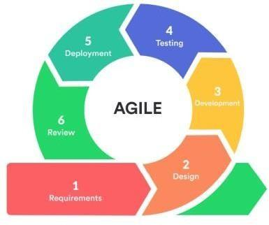

Figure 3.1: Agile Model

**Use Case Diagram**

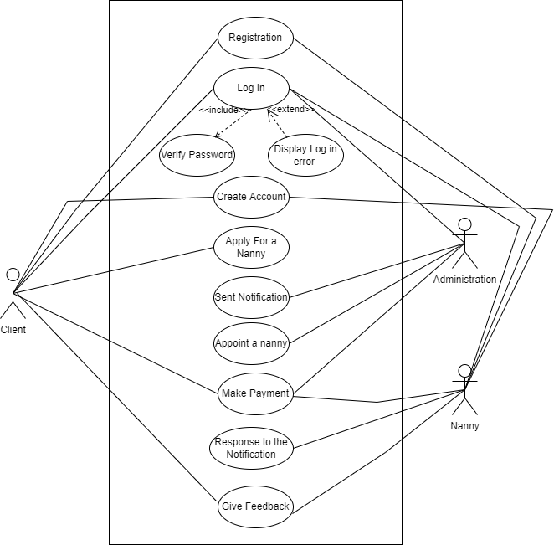

Figure 3.2: Use Case Diagram

**Use Case Description**

## Login

|  |  |  |  |
| --- | --- | --- | --- |
| **Use Case ID** | UC-01 | | |
| **Use Case Name** | Login / Sign in | | |
| **Goal** | Login to the system | | |
| **Preconditions** | User must be register with their email and correct password | | |
| **Primary Actor Secondary Actor** | Admin, User | | |
| **Trigger** | Button | | |
| **Description / Main**  **success scenario** | Step | Action |  |
| 1 | To enter into the system |
| 2 | To access the required feature |
| **Post Condition** | User can login any time | | |
| **Alternative Flow** | Sign up | | |

## Registration

|  |  |  |  |
| --- | --- | --- | --- |
| **Use Case ID** | UC-02 | | |
| **Use Case Name** | Sign up | | |
| **Goal** | To create a new user profile | | |
| **Preconditions** | User must have an email account | | |
| **Primary Actor Secondary Actor** | Admin, user | | |
| **Trigger** | Button | | |
| **Description / Main**  **success scenario** | Step | Action |  |
| 1 | To enter into the system |
| 2 | To create a new user profile |
| **Post Condition** | User can login any time | | |
| **Alternative Flow** | N/A | | |

|  |  |  |  |
| --- | --- | --- | --- |
| **Use Case ID** | UC-03 | | |
| **Use Case Name** | Profile | | |
| **Goal** | Access into user profile | | |
| **Preconditions** | User must login to the system | | |
| **Primary Actor Secondary Actor** | Admin, User | | |
| **Trigger** | Button | | |
| **Description / Main**  **success scenario** | Step | Action |  |
| 1 | To login |
| 2 | To access user profile |
| **Post Condition** | User can view and edit profile | | |
| **Alternative Flow** | N/A | | |

## 3.3.4 Share Post

|  |  |  |  |
| --- | --- | --- | --- |
| **Use Case ID** | UC-04 | | |
| **Use Case Name** | Share Post | | |
| **Goal** | To share their post | | |
| **Preconditions** | User must login to the system | | |
| **Primary Actor Secondary Actor** | user | | |
| **Trigger** | Button | | |
| **Description / Main**  **success scenario** |  | Action |  |
| 1 | To login |
| 2 | Write post to timeline |
| 3 | Save and share the post |
| **Post Condition** | User can edit and delete their post | | |
| **Alternative Flow** | N/A | | |

|  |  |  |  |
| --- | --- | --- | --- |
| **Use Case ID** | UC-05 | | |
| **Use Case Name** | Booking | | |
| **Goal** | To book a babysitter | | |
| **Preconditions** | User have to go to their profile | | |
| **Primary Actor Secondary Actor** | Parent, admin, babysitter | | |
| **Trigger** | Button | | |
| **Description / Main**  **success scenario** | Step | Action |  |
| 1 | Go profile |
| 2 | pick a date |
| 3 | Send booking request |  |
| 4 | Accept booking request |  |
| 5 | Confirm Booking |  |
| **Post Condition** | User can view and Update their activities | | |
| **Alternative Flow** | N/A | | |

## 3.3.6 Chat Bot

|  |  |  |  |
| --- | --- | --- | --- |
| **Use Case ID** | UC-06 | | |
| **Use Case Name** | Chat Bot | | |
| **Goal** | Communication | | |
| **Preconditions** | User must login to the system | | |
| **Primary Actor Secondary Actor** | User | | |
| **Trigger** | Button | | |
| **Description / Main**  **success scenario** | Step | Action |  |
| 1 | To login |
| 2 | Chat though AI |
| **Post Condition** | User can view their conversations | | |
| **Alternative Flow** | N/A | | |

|  |  |  |  |
| --- | --- | --- | --- |
| **Use Case ID** | UC-07 | | |
| **Use Case Name** | Blog | | |
| **Goal** | Admin to upload, edit Audio & video. User to view. | | |
| **Preconditions** | User & Admin must login to the system | | |
| **Primary Actor Secondary Actor** | Admin User | | |
| **Trigger** | Button | | |
| **Description / Main**  **success scenario** | Step | Action |  |
| 1 | Go to blog |
| 2 | Upload/edit blog |
| 3 | Save & update |
| **Post Condition** | User can view and admin can edit | | |
| **Alternative Flow** | N/A | | |

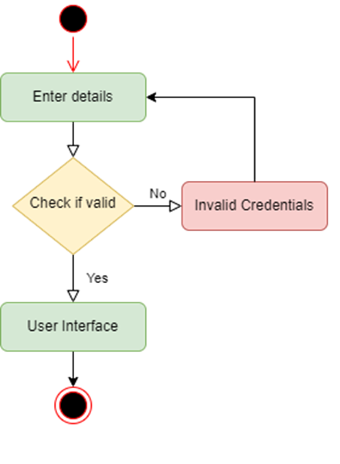

Activity Diagram (Login)

Activity Diagram (Registration)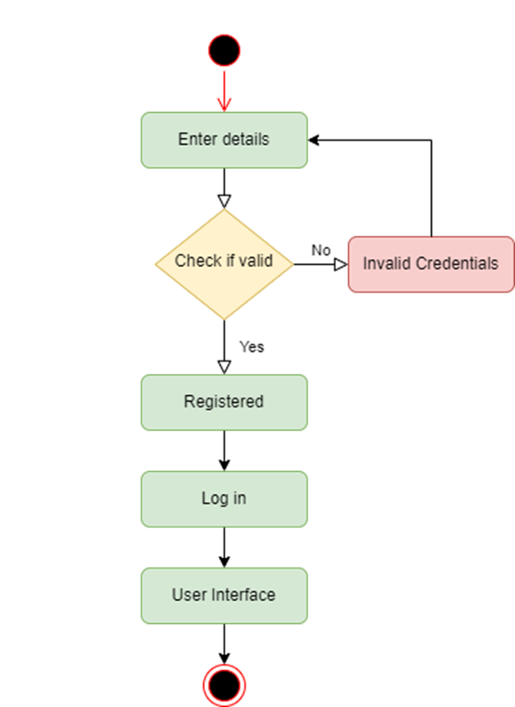

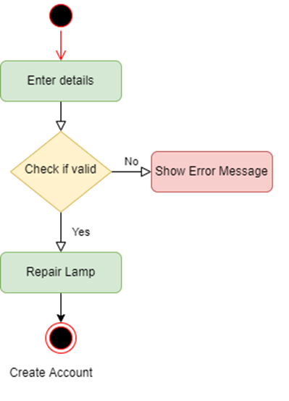

Activity Diagram (Create Account)

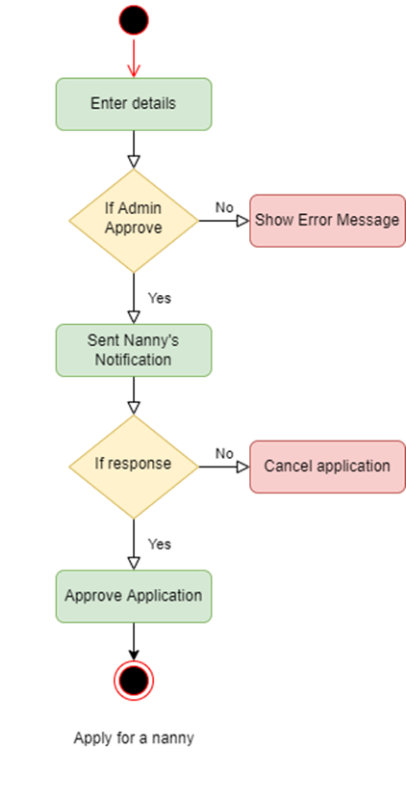

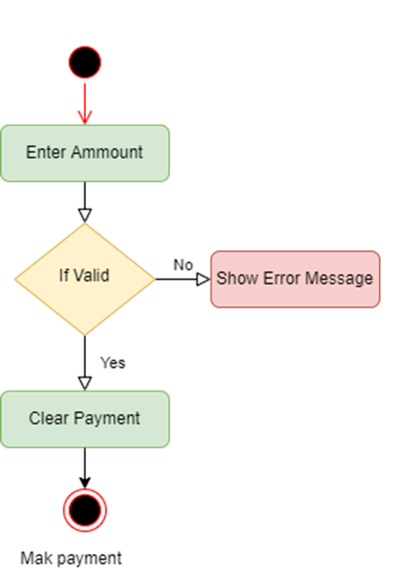

## 3.5.1 Registration

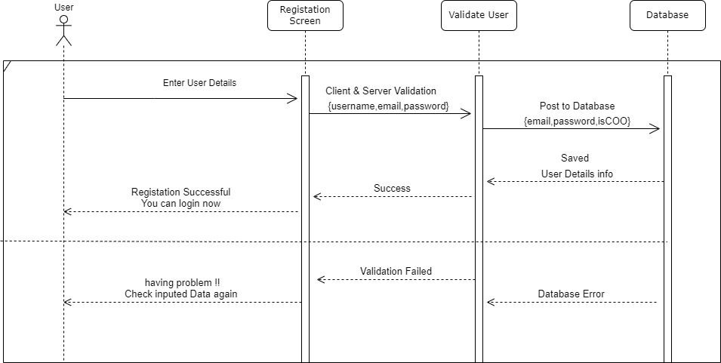

## 3.5.2 Log in

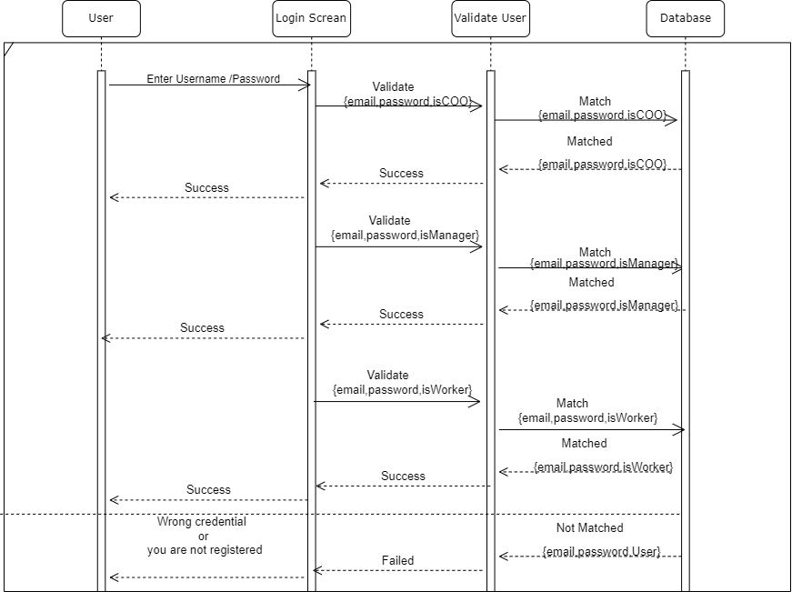

## 3.5.3 Create Profile

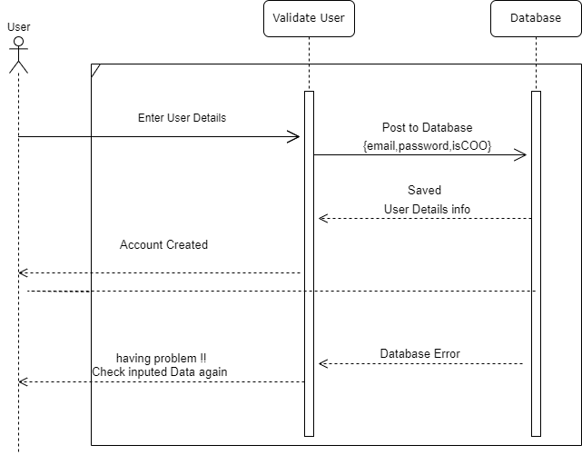

## 3.5.4 Find a Nanny

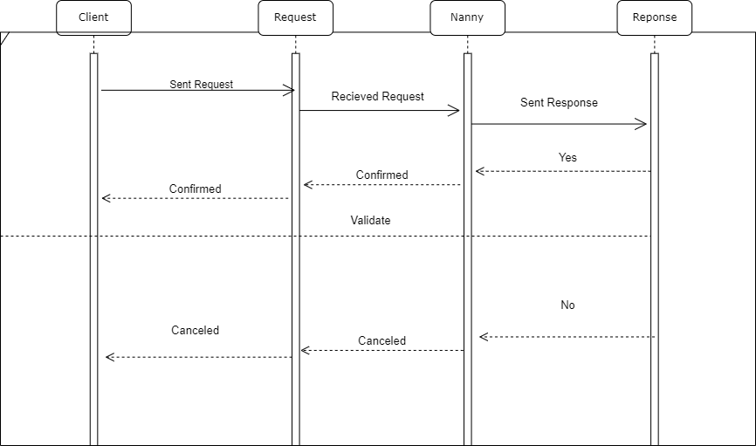

## 3.5.4 make payment

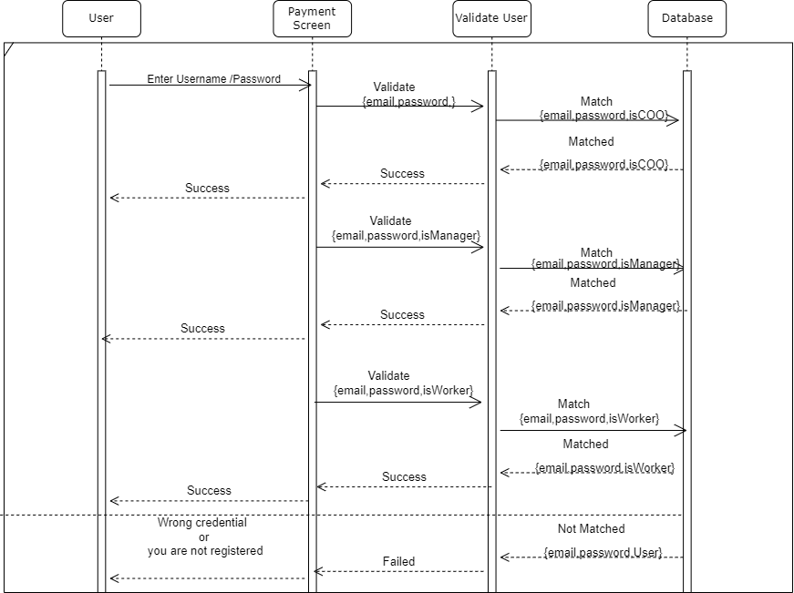

## 3.5.5 write blog

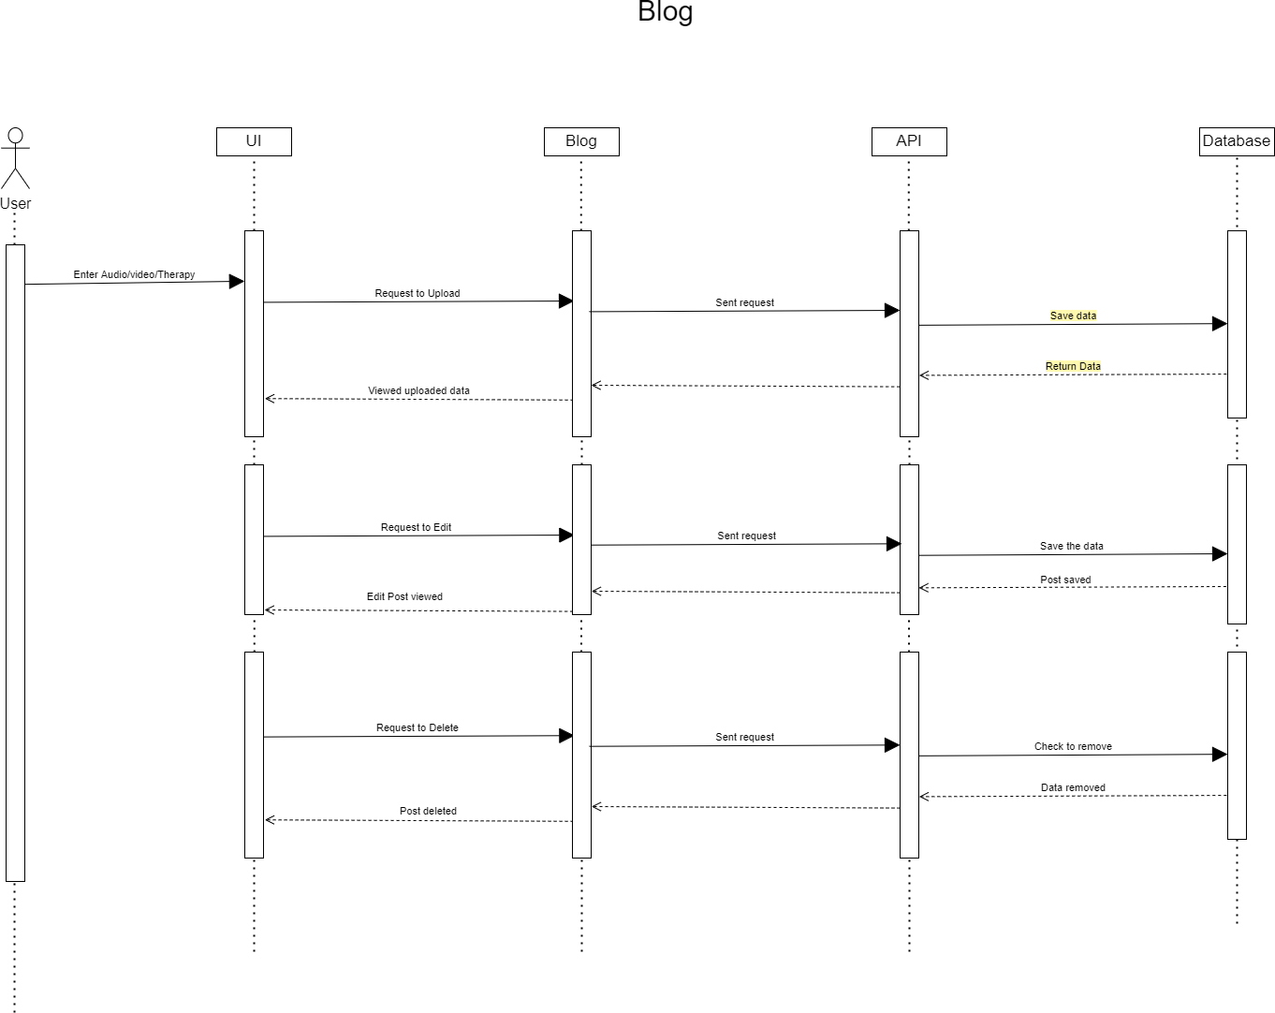

# ERD Diagram

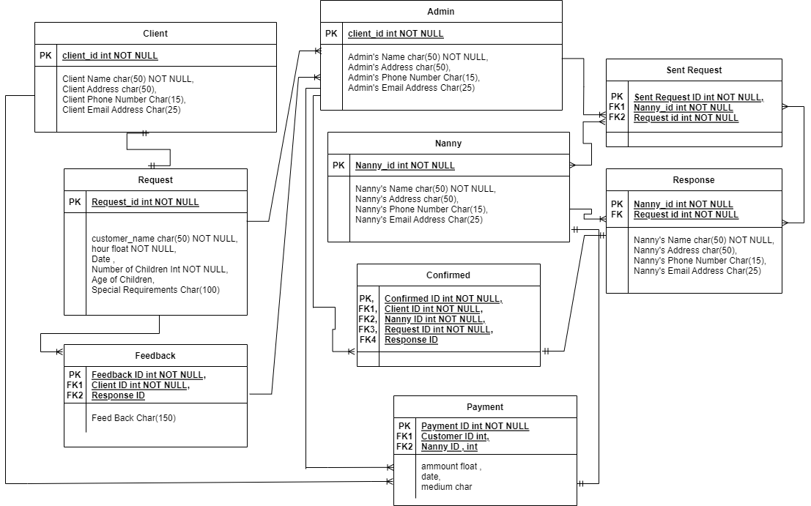

# CHAPTER 4 SYSTEM TESTING

Web applications need to be updated from time to time. Feature testing is a way of adding functionality or modifying to be matched by new technology. After the feature testing every application becomes more reliable, secure and efficient.

## 4.1.1 Tested Feature

|  |  |  |
| --- | --- | --- |
| **Feature** | **Priority** | **Description** |
| Login | 1 | The user must be authenticating by login |
| Logout | 2 | The session must be finished by log out |
| Registration | 1 | User info must be saved |
| View Profile | 2 | User can see their profile info |
| Dashboard | 1 | Admin can manage all activities from dashboard |
| Post Sharing | 1 | User can share their feelings |
| Book Babysitter | 1 | User can check their daily mood |
| Blog | 2 | Admin can post blog |

**Here, 1= High Priority, 2= Medium Priority, 3= Low Priority**

## Test Approach

To ensure the quality of my project system, I want to use two different testing, 1. Black box testing, 2. White box testing

They focused mainly on functional testing and structural testing.

* + - 1. **Black Box Testing:** Black Box testing is used to test functionality of the system. Functionality is tested based on input and output.
      2. **White box testing:** White box testing is used to tested structure, architecture and mechanism of a system.

## Pass / Fail Criteria:

For testing, there are 2 type of criteria –Pass and Fail. The Pass / Fail criteria is prepared based on which output is right which output is wrong.

* System Crash is considered as a failure case.
* If any criteria pass 100% of testing, then it will be considered as pass criteria only.

|  |  |
| --- | --- |
| **Test Phase** | **Time** |
| Testing plan create | 1 week |
| Unit testing | During developing time |
| Component testing | During developing time |
| Integration testing | 1 week |
| Testing user interface | 1week |
| Load testing | 1 week |
| Performance testing | 1 week |
| Accessibility testing | 1 week |

Table 4.2: Testing Schedule

|  |  |  |  |  |
| --- | --- | --- | --- | --- |
| **Project Manager** | | | **Business analyst Lead** | |
| **QA leader** | | | **Target implementation date** | |
| **TM** | **Functionality Activity** | **Requirement Description** | **Test Case Referance** | **Comments** |
| TM-01 | Functional | Registration | TEST CASE 4.4.1 |  |
| TM-02 | Functional | Login | TEST CASE 4.4.2 |  |
| TM-03 | Functional | View Profile | TEST CASE 4.4.3 |  |
| TM-04 | Functional | Post Share | TEST CASE 4.4.4 |  |
| TM-05 | Functional | Booking Nanny | TEST CASE 4.4.5 |  |
| TM-06 | Functional | Blog | TEST CASE 4.4.6 |  |
| TM-07 | Functional | Quiz | TEST CASE 4.4.7 |  |
| TM-08 | Functional | Logout | TEST CASE 4.4.8 |  |

Table 4.3: Traceability Matrix

Testing environment is made with hardware and software, so that the tester may execute what tests mean. There are few testings’ region for testing environments which I used for my project testing.

* Test data
* Web Server
* Database Server
* Frontend running environment
* Back end running environment
* Network
* Browser

## 4.4.1 Registration

|  |  |  |  |  |  |  |  |  |
| --- | --- | --- | --- | --- | --- | --- | --- | --- |
| **Test Case:** 01 | | | | **Test Case Name:** Registration | | | | |
| **System:** | | | | **Sub-System:** | | | | |
| **Designed by:** Jannatul Ferdous Shova | | | | **Designed date:** | | | | |
| **Executed by:** | | | | **Executed date:** | | | | |
| **Short Description:** System will save new user description | | | | | | | | |
| **Pre-condition:**   * User must be have valid name, email | | | | | | | | |
| **Serial** | **Name** | **Email** | **Password** | | **Expected Result** | **Pass / Fail** | **Actual Result** | **Comment** |
| 1 | Shova |  | 09876 | | Email field is required | Fail | Pass |  |
| 2 | Shova | Shova | Shova | | Invalid email | Fail | Pass |  |
| 3 | Shova | Shova@001 gmail.com | 321564 | | Successfully signed up | Pass | Pass |  |
| **Post-Condition:** User can log in | | | | | | | | |

|  |  |  |  |  |  |  |  |
| --- | --- | --- | --- | --- | --- | --- | --- |
| **Test Case:** 02 | | | **Test Case Name:** Log in | | | | |
| **System:** | | | **Sub-System:** | | | | |
| **Designed by:** Shova | | | **Designed date:** | | | | |
| **Executed by:** | | | **Executed date:** | | | | |
| **Short Description:** User can access in to the system | | | | | | | |
| **Pre-condition:**   * User must be have valid email and password | | | | | | | |
| **Serial** | **Email** | **Password** | | **Expected Result** | **Pass / Fail** | **Actual Result** | **Comment** |
| 1 |  | 09876 | | Email field is required | Fail | Pass |  |
| 2 | Shova | Shova | | Invalid email | Fail | Pass |  |
| 3 |  |  | | Email and Password field is required | Fail | Pass |  |
| 4 | Shova[@002gmail.com](mailto:mou@001gmail.com) | 321564 | | Successfully signed up | Pass | Pass |  |
| **Post-Condition:** User can log in | | | | | | | |

|  |  |  |  |  |  |  |
| --- | --- | --- | --- | --- | --- | --- |
| **Test Case:** 03 | | | **Test Case Name:** Profile | | | |
| **System:** | | | **Sub-System:** | | | |
| **Designed by:**Shova | | | **Designed date:** | | | |
| **Executed by:** | | | **Executed date:** | | | |
| **Short Description:** User view their profile information | | | | | | |
| **Pre-condition:**   * User must have their own account and also logged in to their account | | | | | | |
| **Serial** | **Action** | **Expected Result** | | **Pass / Fail** | **Actual Result** | **Comment** |
| 1 | Click on profile option | Open profile information | | Pass | Pass |  |
| **Post-Condition:** User can edit their profile info | | | | | | |

|  |  |  |  |  |  |  |
| --- | --- | --- | --- | --- | --- | --- |
| **Test Case:** 04 | | | **Test Case Name:** Post Share | | | |
| **System:** | | | **Sub-System:** | | | |
| **Designed by:** Shova | | | **Designed date:** | | | |
| **Executed by:** | | | **Executed date:** | | | |
| **Short Description:** User can share their post | | | | | | |
| **Pre-condition:**   * User must have their own account and also logged in to their account | | | | | | |
| **Serial** | **Action** | **Expected Result** | | **Pass / Fail** | **Actual Result** | **Comment** |
| 1 | Share post | Write post on timeline | | Pass | Pass |  |
| **Post-Condition:** User can view their post | | | | | | |

|  |  |  |  |  |  |  |
| --- | --- | --- | --- | --- | --- | --- |
| **Test Case:** 05 | | | **Test Case Name:** Book nanny | | | |
| **System:** | | | **Sub-System:** | | | |
| **Designed by:** Shova | | | **Designed date:** | | | |
| **Executed by:** | | | **Executed date:** | | | |
| **Short Description:** User book nanny | | | | | | |
| **Pre-condition:**   * User must have their own account and also logged in to their account | | | | | | |
| **Serial** | **Action** | **Expected Result** | | **Pass / Fail** | **Actual Result** | **Comment** |
| 1 | Booking | Check options | | Pass | Pass |  |
| **Post-Condition:** User can edit their profile info | | | | | | |

|  |  |  |  |  |  |  |
| --- | --- | --- | --- | --- | --- | --- |
| **Test Case:** 06 | | | **Test Case Name:** Blog | | | |
| **System:** | | | **Sub-System:** | | | |
| **Designed by:** Shova | | | **Designed date:** | | | |
| **Executed by:** | | | **Executed date:** | | | |
| **Short Description:** User can view Blog | | | | | | |
| **Pre-condition:**   * User must have their own account and also logged in to their account | | | | | | |
| **Serial** | **Action** | **Expected Result** | | **Pass / Fail** | **Actual Result** | **Comment** |
| 1 | Click on Blog | View Blog | | Pass | Pass |  |
| **Post-Condition:** Admin can update blog | | | | | | |

|  |  |  |  |  |  |  |
| --- | --- | --- | --- | --- | --- | --- |
| **Test Case:** 07 | | | **Test Case Name: L**ogout | | | |
| **System:** | | | **Sub-System:** | | | |
| **Designed by:** Shova | | | **Designed date:** | | | |
| **Executed by:** | | | **Executed date:** | | | |
| **Short Description:** system will close | | | | | | |
| **Pre-condition:**   * User must logged in to the system | | | | | | |
| **Serial** | **Action** | **Expected Result** | | **Pass / Fail** | **Actual Result** | **Comment** |
| 1 | Click logout button | Session ended | | Pass | Pass |  |
| **Post-Condition:** User can log in again | | | | | | |

**CHAPTER 5 USER MANUAL**

**Login & Registration Page**

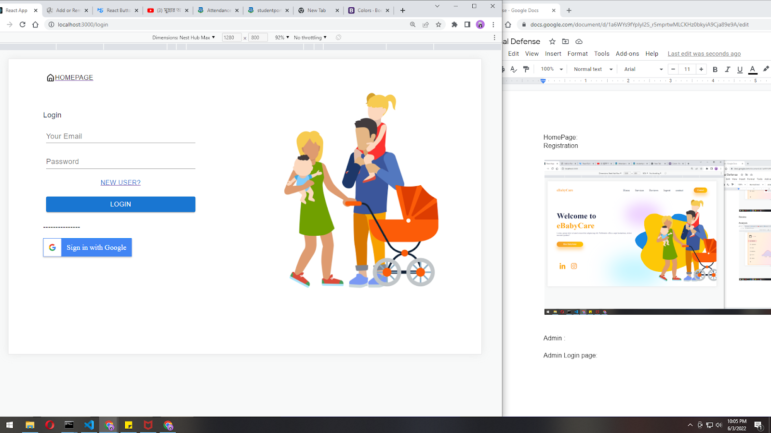

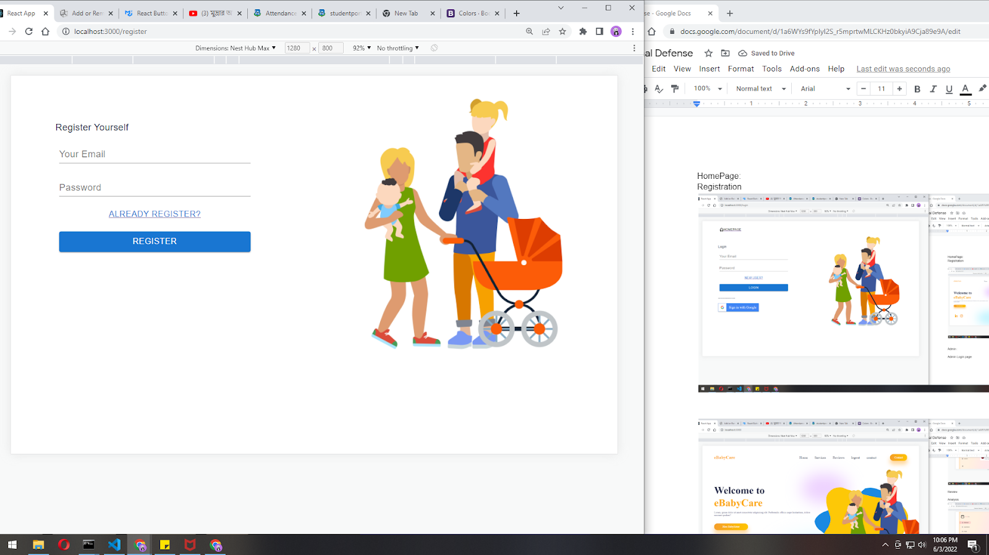

**Home Page**

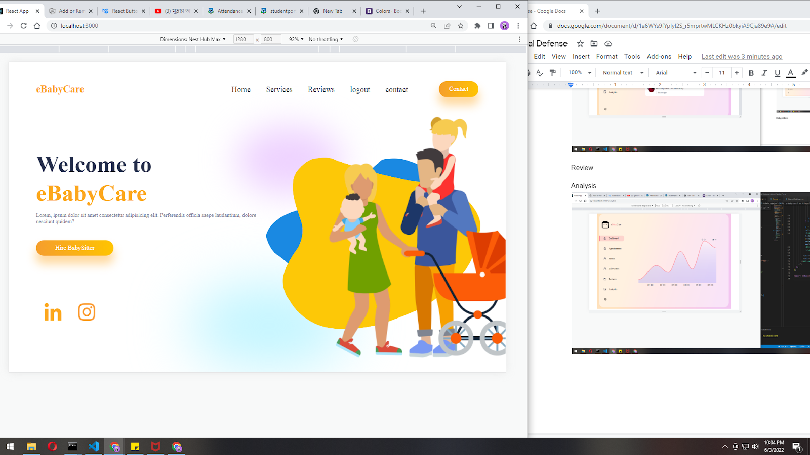

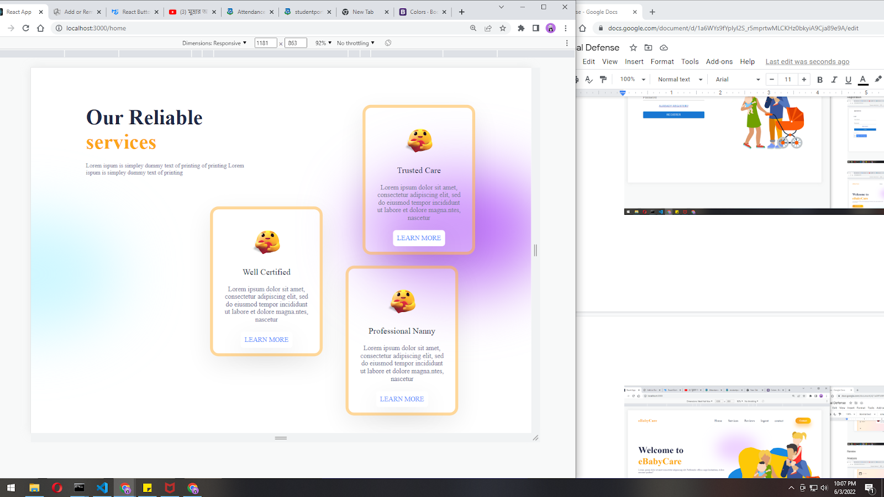

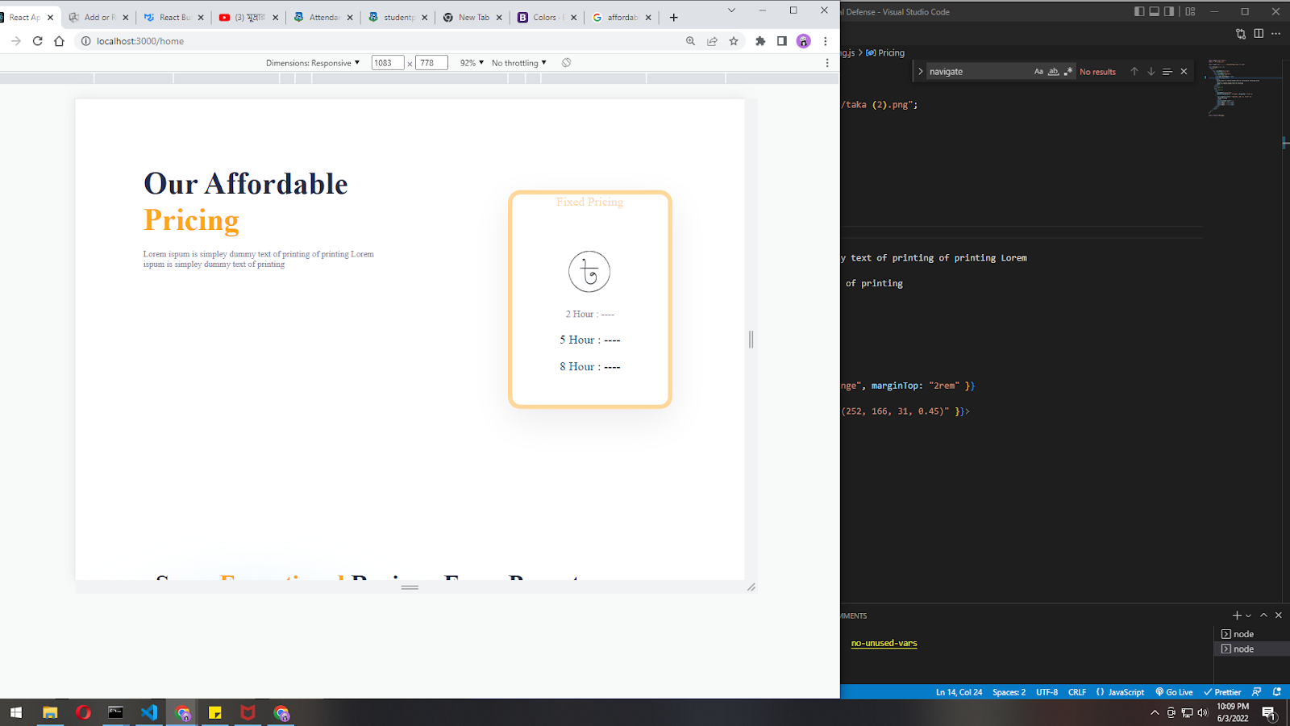

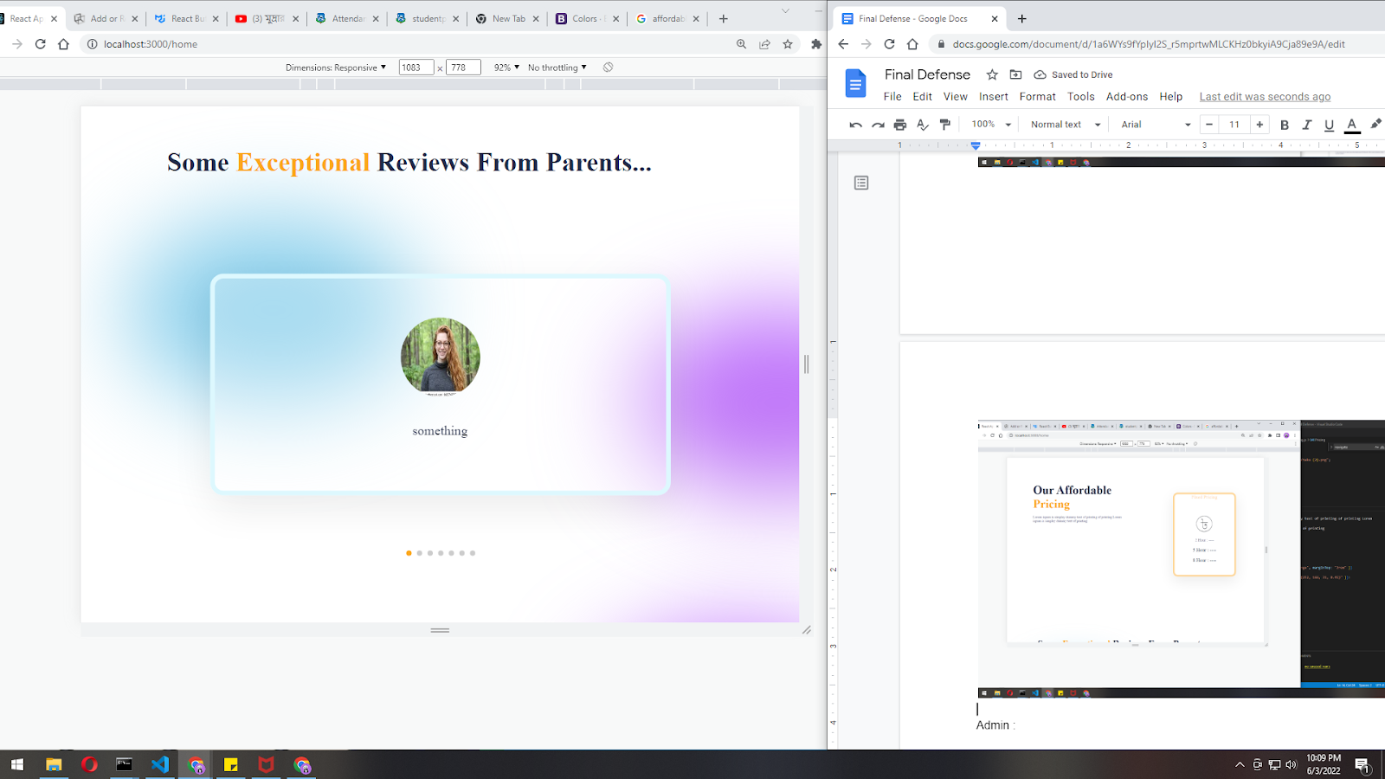

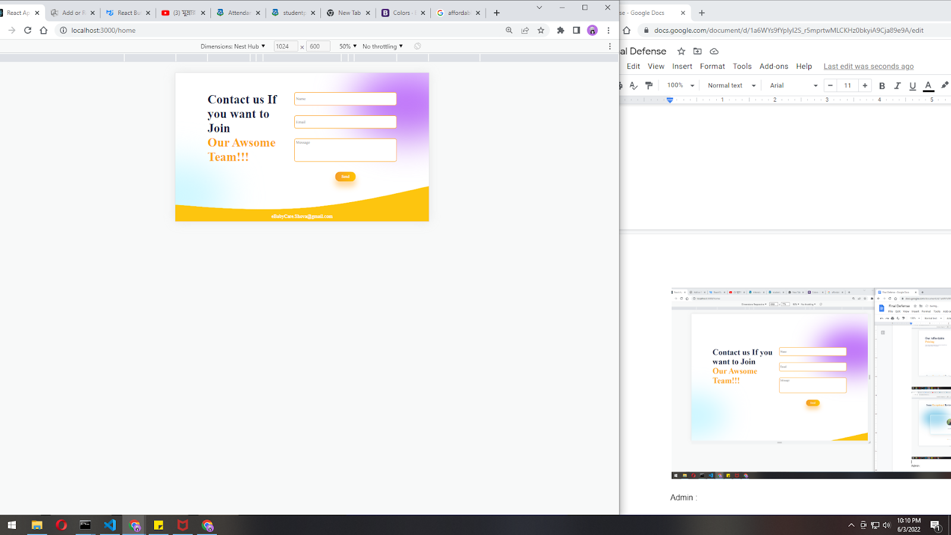

**Responsive Homepage**

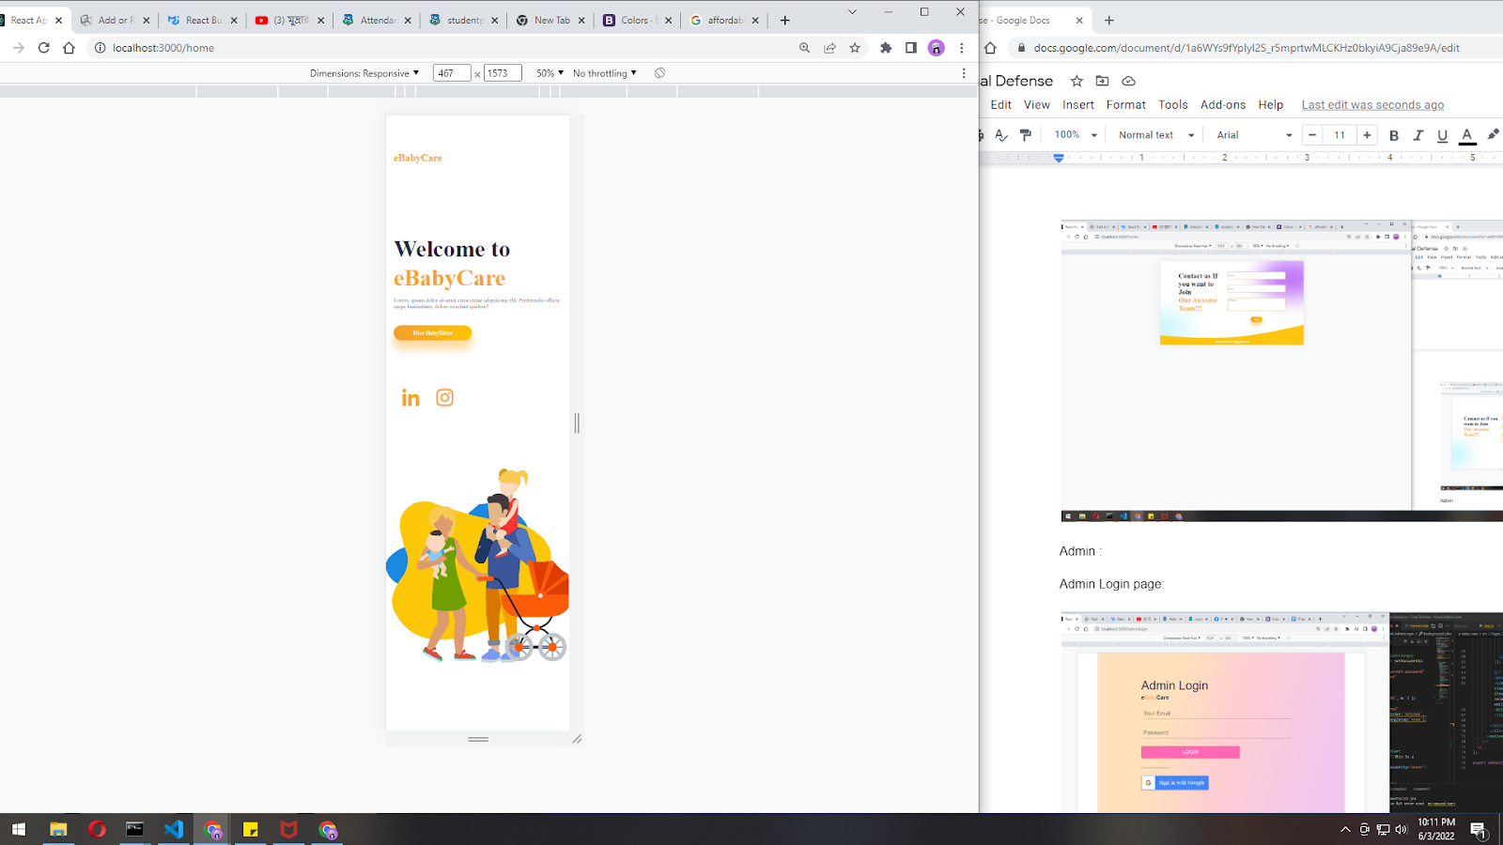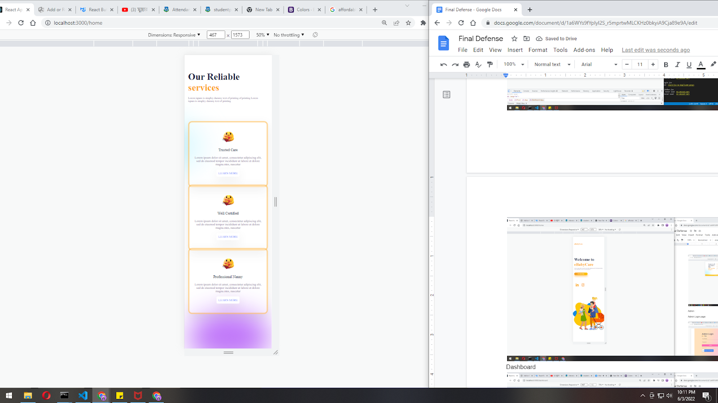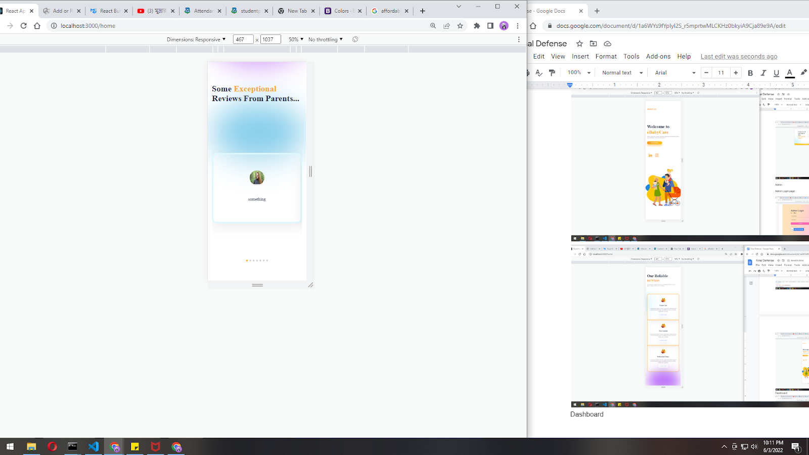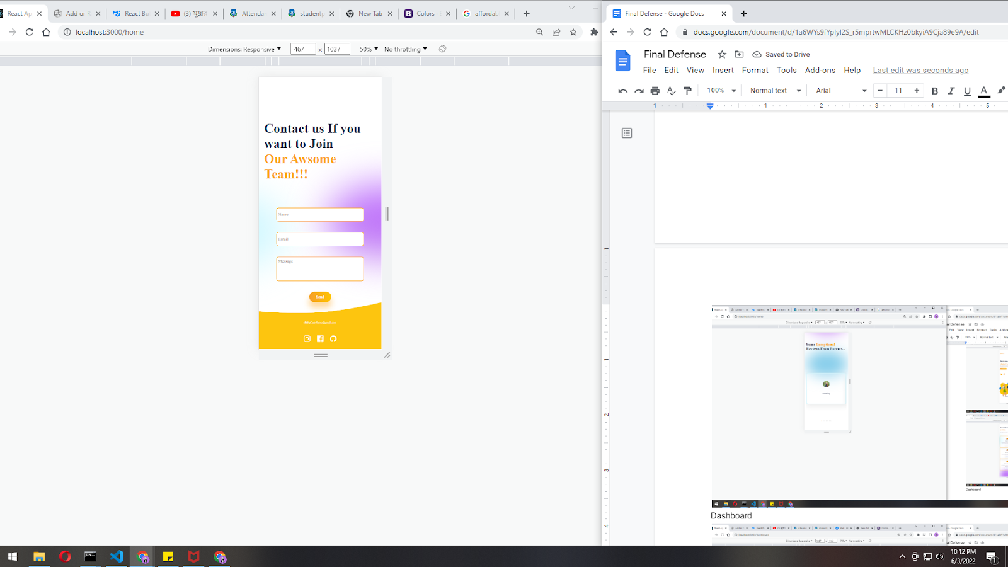

**Admin Login**

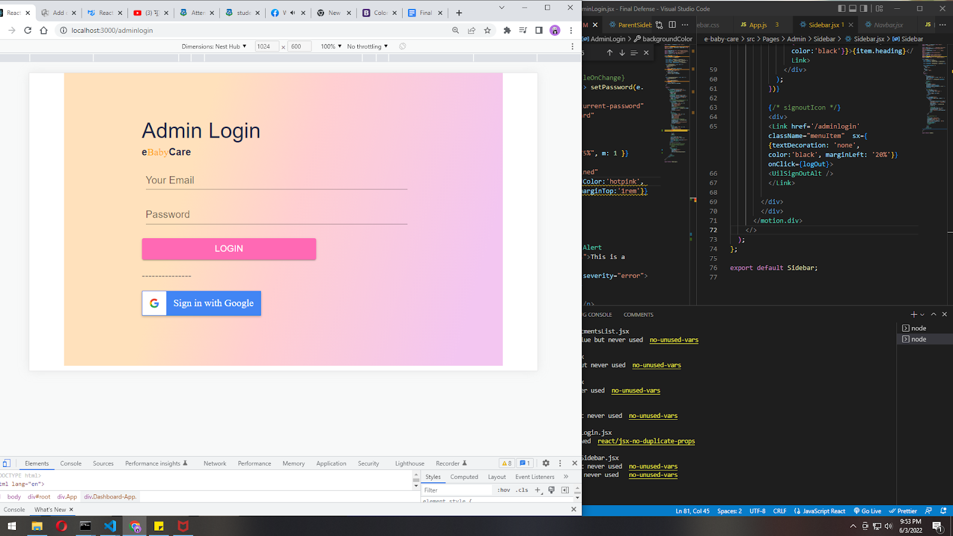

**Admin Dashboard**

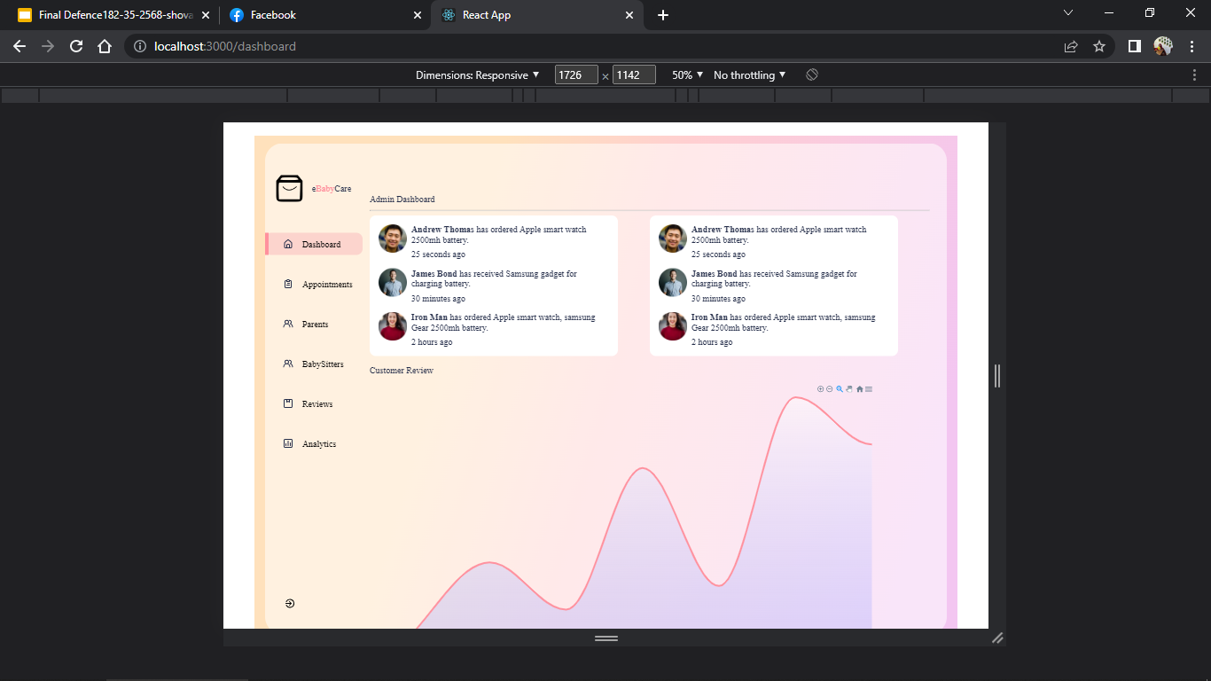

**Appointment List**

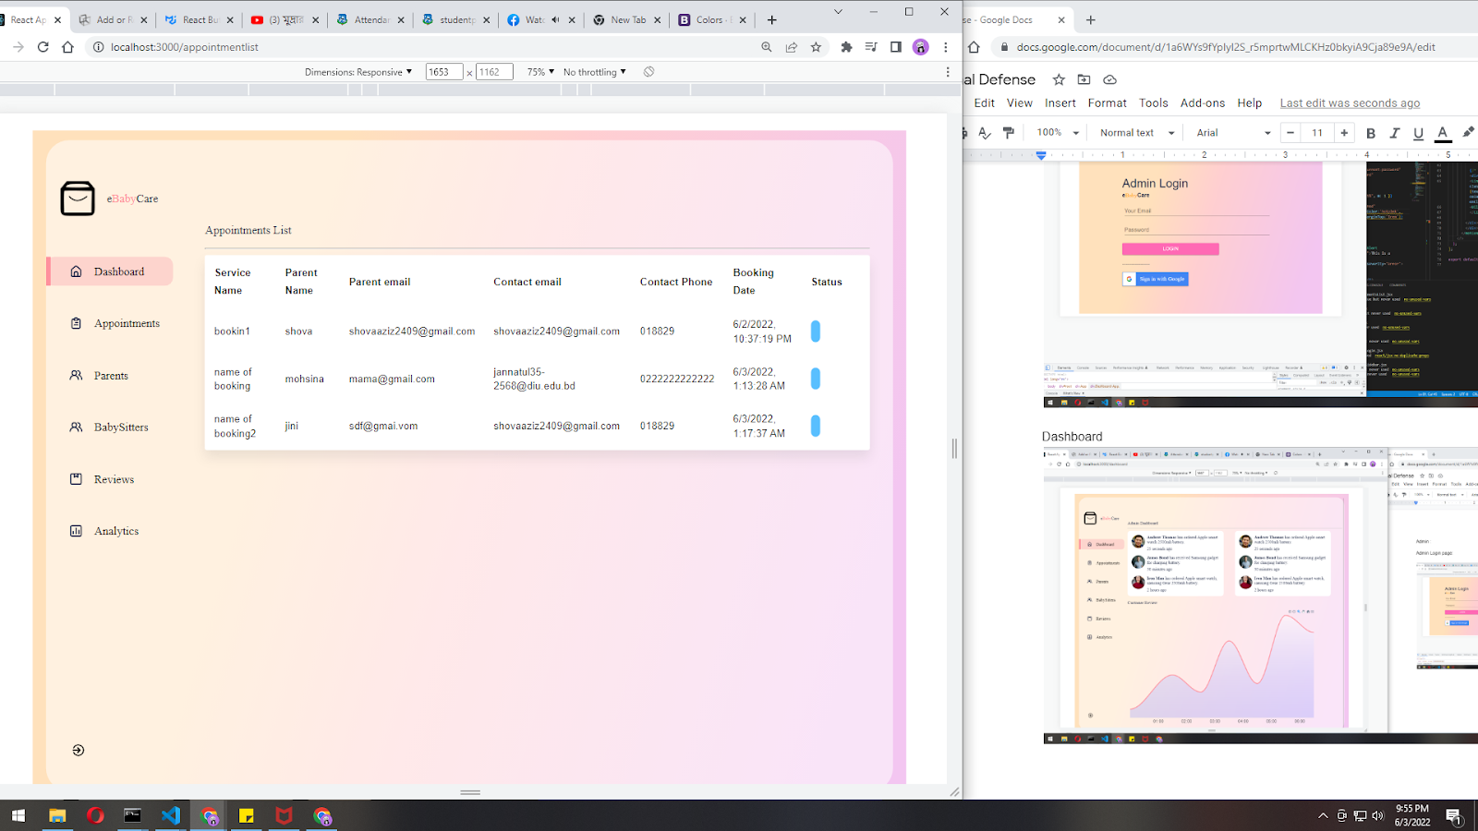

**Parents List**

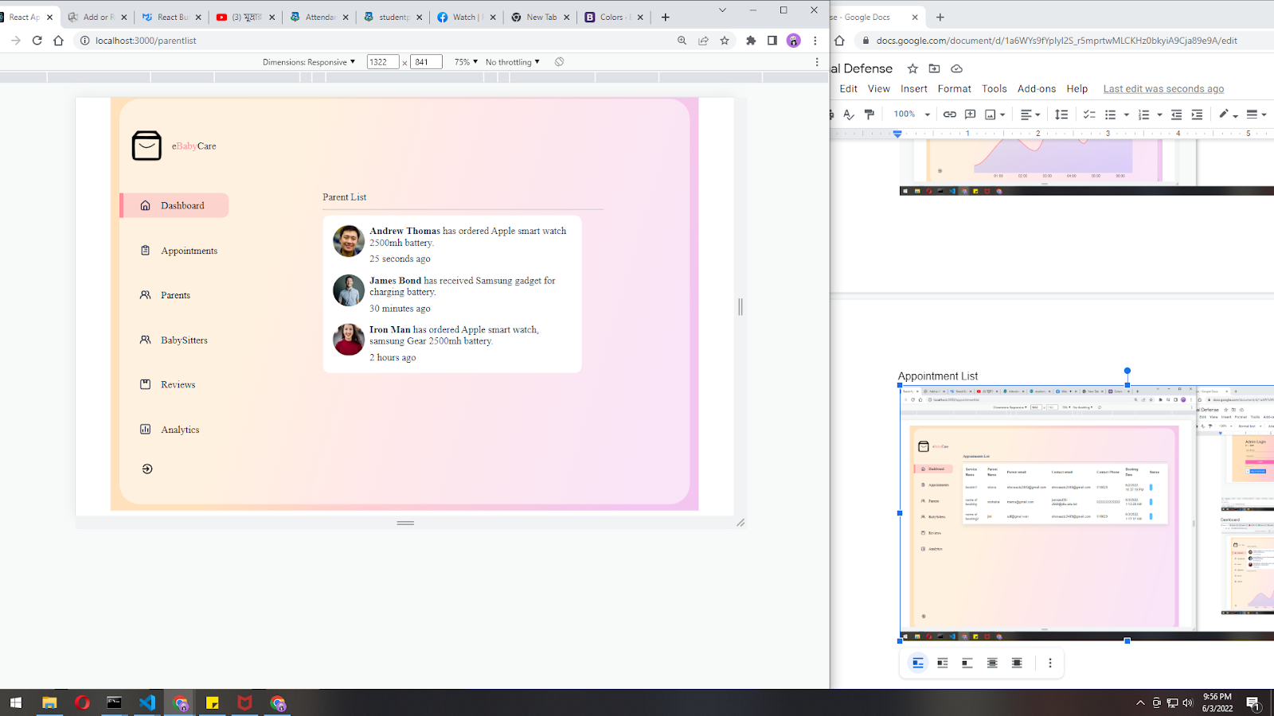

**Baby Sitters**

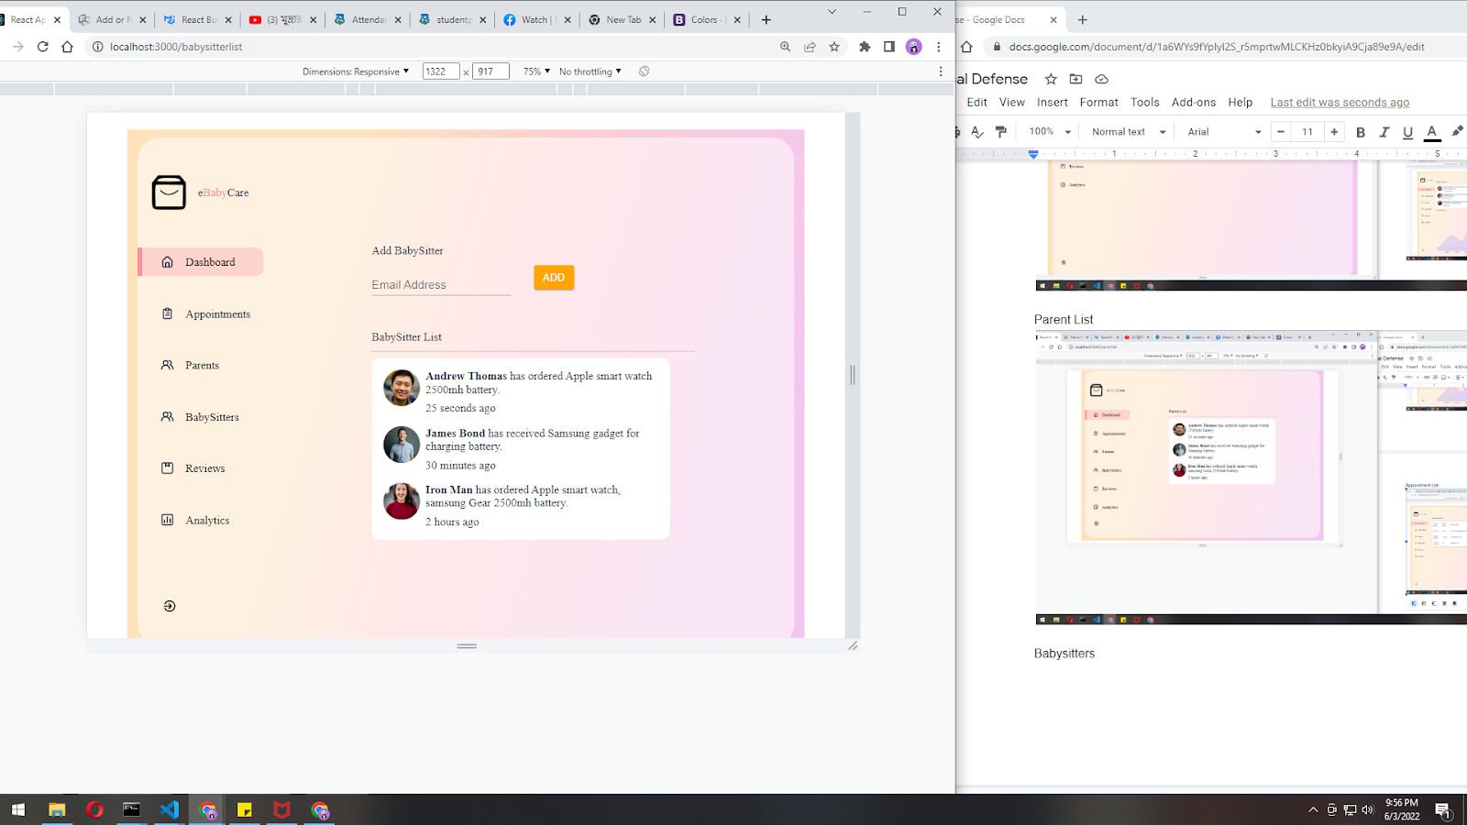

**Review List**

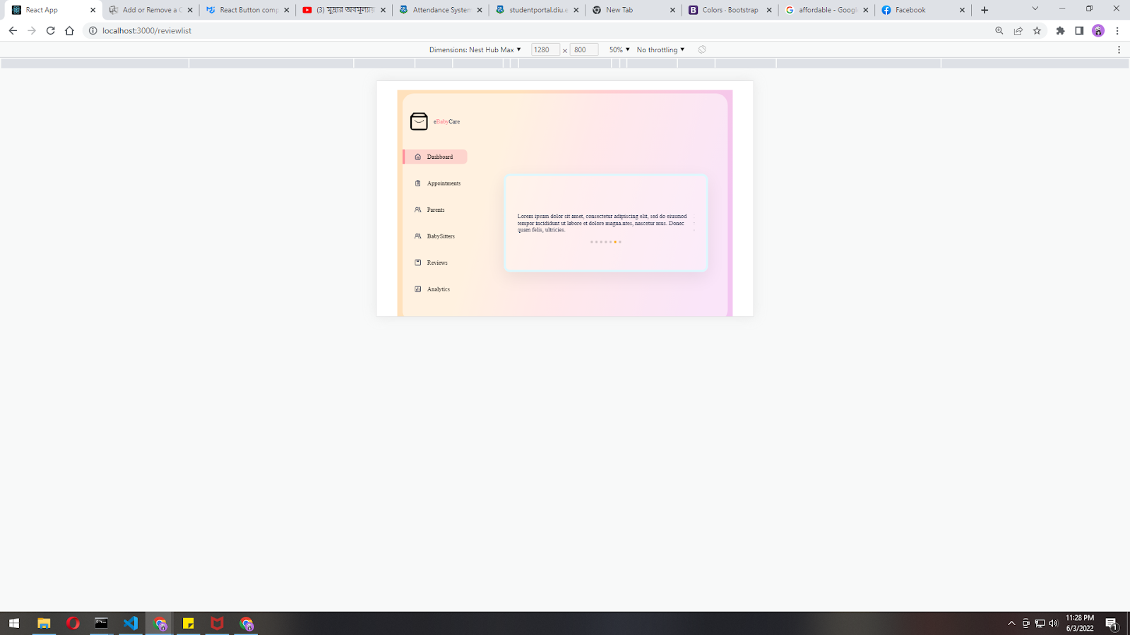

**Review Analysis**

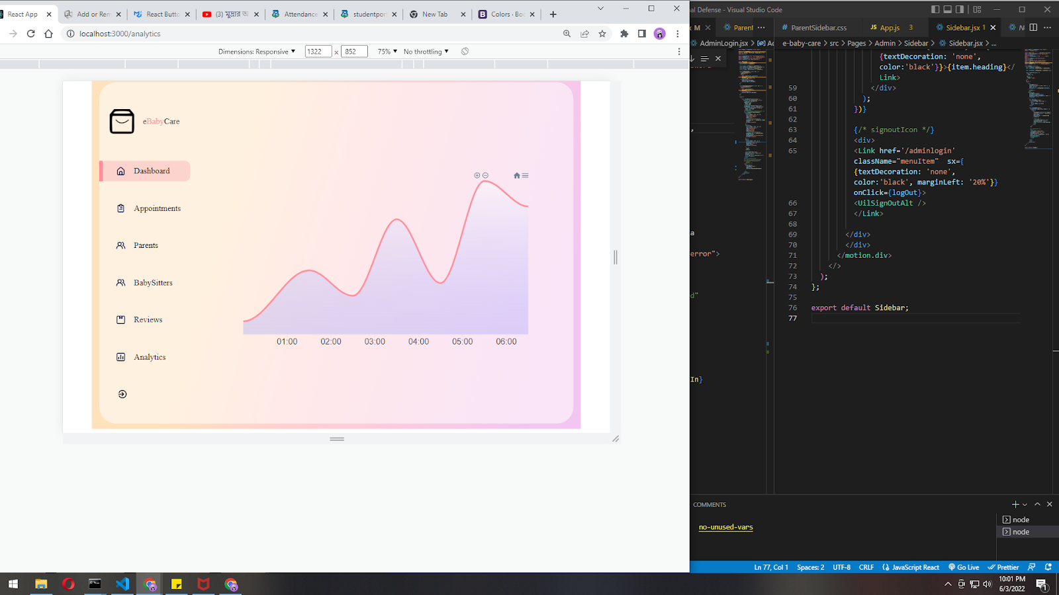

**Parent Dashboard**

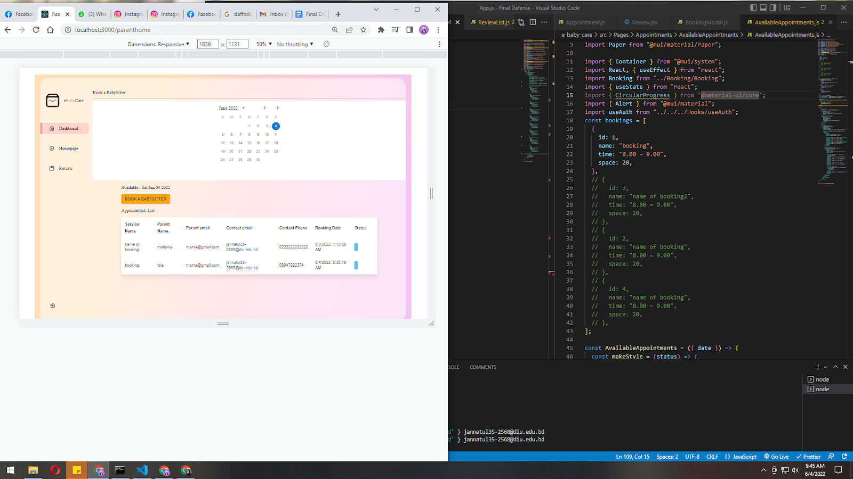

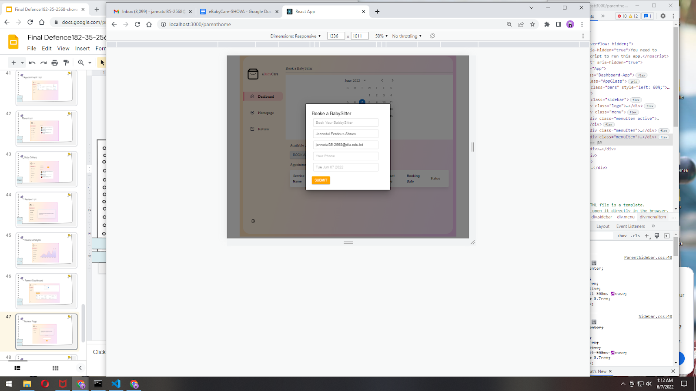

**Review Page**

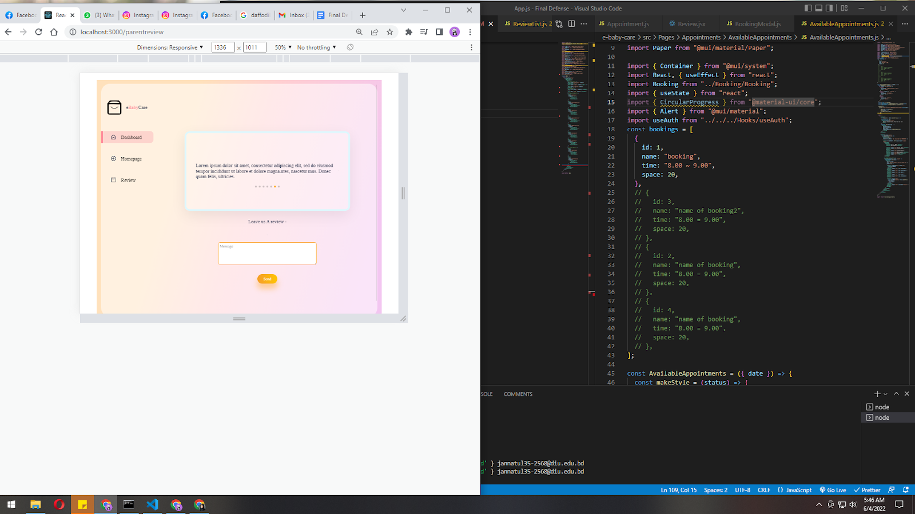

# CHAPTER 6 CONCLUSION

## Project Summery

eBabyCare can add a new earning platform to the scocity. And also ease the struggle of the working parents. Such platform is the demand of new era.

## Limitation

* + - Not fully responsive
    - It is a web-based system only
    - Automation is required
    - This system is not a certified system
    - Not fully secure

## Obstacles and Achievement

To walk within the great way, one’s meet many obstacles and then they get some achievement. I thought I even done it by taking help from my friends, Supervisor, Co-Supervisor and searching many things and answer from Google. I achieve the confident to finish this project by myself.

## Future Scope

* + - Mobile application can be developed
    - Automation of some features
    - A certified system can be developed.

Accounts and Library Clearance:

